To: TxDOT District Office
From: Arian Smith
Date: June 22, 2021
Subject: Proposal to Lower Speed Limit in Fossil Park Neighborhood

Summary of the proposal
Parked vehicle accidents in the Fossil Park neighborhood are a reoccurring hardship on homeowners. Often these are hit and run incidents where insurance cannot even cover the cost or repair or replacement. Current City of Fort Worth speed limit for neighborhood streets is 30 mph. Lowering the speed limit to 20 mph would decrease parked vehicle accidents.

Definition of the Problem/Definition of the Situation
City of Fort Worth speed limit for neighborhood streets is 30 mph. As such, the neighborhood of Fossil Park is posted as 30 mph. The neighborhood has only 2 entrance/exits with Fossil Park Drive being the main as it is allows for both left and right turns. There is a city park adjacent to Fossil Park Drive and a Deaf Child sign is posted on that road. There are no sidewalks present.

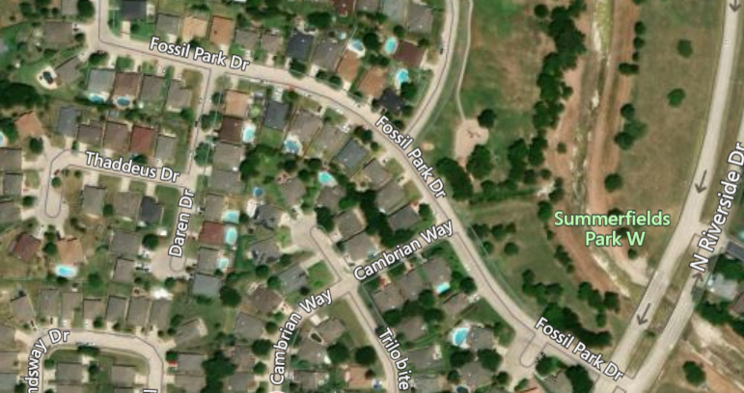
Fossil Park Dr is the main entrance/exit
Deaf Child Sign Posted

Per Texas Transportation Code Chapter 550, TxDOT records crash data as it is reported. This database allows for analysis of problematic areas. Unfortunately, because accidents involving parked vehicles are not reported, we cannot use this data to fully recognize the issue. Lack of reporting if for a few reasons. First, most involve hit and run with no identifying information left behind. Second, fault is determined when one vehicle is parked so the need for a police officer report is nonexistent. Third, the police are not able to assist in remedying the damage.

However, the case remains that accidents involving parked vehicles is common in residential areas, not just the neighborhood of Fossil Park. The incidents are costly to the residents. Even if a homeowner has insurance, they are responsible for their deductible. Per state law, only liability insurance is required so some vehicles lack comprehensive insurance to file a claim. Parked vehicle accident costs range from hundreds to thousands in damages. It can even total a vehicle.
Accidents also cause bodily injury to those in the moving vehicle. Per the Traffic School Online’s Defensive Driving Course, “a collision at 30 mph has the same impact force as if it fell from a building of four floors (School)”. They also state that loose objects at this same speed have force equivalent to being shot out of a cannon (School). This applies to both loose objects such as bags, bottles, and debris as well as your head!

Traveling 30 mph along a curved roadway is dangerous to children and pets, especially if there are no sidewalks as is the case with Fossil Park Drive. CSGNetwork.com published a report noting vehicle stopping distance and time. In this report, it states a vehicle traveling 30 mph will stop at a rate of 44 ft per second (CSG). The total stopping distance is 109 ft (CSG). That is approximately one third of a city block! With beloved children and pets playing at or near the park, that is too long a distance to stop when avoiding hitting them.

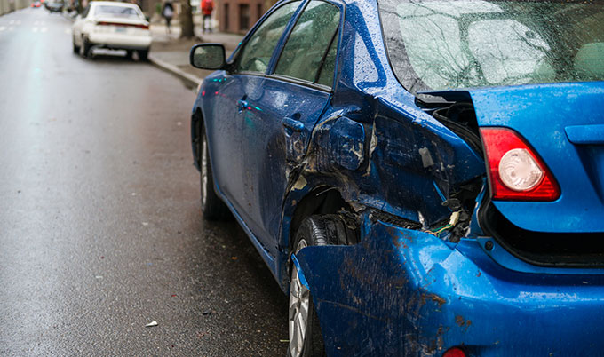
(Allstate)

Objectives
By lowering the speed limit in Fossil Park, we can decrease the parked vehicle accidents. This will also lower all vehicle accidents. As such, injuries to those in the moving vehicle will be reduced. Collision damaging property will decrease saving homeowners hundreds and thousands of dollars. Most importantly, lowering the speed limit reduces the chances of an injury or fatality to a loved one.

To make this change, three tasks need to be accomplished.
- An inquiry needs to be posted on the Nextdoor app stirring interest.
- A petition needs to be signed by the majority of homeowners residing in Fossil Park.
- A letter needs to be composed and sent along with the petition to TxDOT requesting a speed limit change.

Threats and Weaknesses
There are two potential threats to this proposal. First, most homeowners may not want to lower the speed limit and refuse to sign the petition. The benefit of being able to get to work, school, etc. may outweigh potential injury to themselves or others or damages to property. The second potential threat is the TxDOT may choose to ignore the proposal. They are not mandated to change the speed limit.

Needs Assessment
Potential needs of a project include:

- The budget – $1000 for cost of sign and worker pay
- The personnel – TxDOT to create and submit announcement for flyer, City workers to post the new speed sign
- The timeline -

Task/Description | Timeline
Post change of speed in City of Fort Worth Water bill flyer | 1 month
Post change on social media such as Nextdoor app | 1 month
Post new speed limit sign | 2 months

Conclusion
Lowering the speed limit from 30 mph to 20 mph in Fossil Park is important to those living in the neighborhood. This proposal could save individuals thousands of dollars and could even save someone’s life! I ask that you approve this project and welcome your feedback and ideas.

References

Allstate parked vehicle accident - Bing images
Crash Data Analysis and Statistics (txdot.gov)

The Force of Impact During Collision -Traffic School, Drivers Ed Test Answers (way2trafficschool.com)

Vehicle Stopping Distance and Time (csgnetwork.com)


(Photo: City of Fort Worth)
NEW 20 MPH SPEED LIMIT TAKES EFFECT IN FOSSIL PARK

Fort Worth, TX, July 3, 2021 – Drivers need to be cautious traveling through the Fossil Park neighborhood. The new 20 mile-per-hour speed limit will go into effect as speed limit signage is posted in the next week. Drivers will be allowed a 30-day adjustment period before citations will be issued. The reduction in speed is part of the TxDOT’s “Slow Down and Save Lives” initiative. Additional neighborhoods are being evaluated and changes can be expected in the upcoming months.

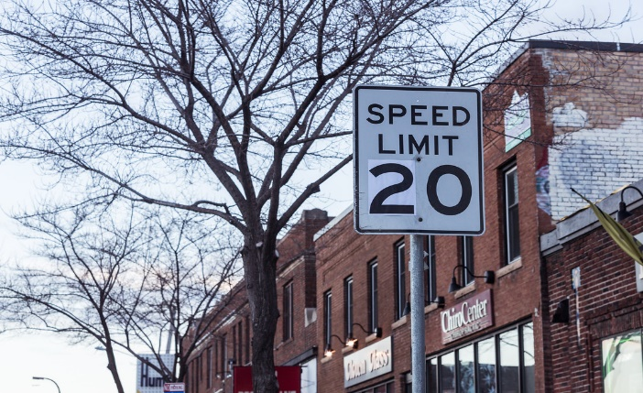
This Photo by Unknown Author is licensed under CC BY-SA
(Photo: City of Fort Worth)

